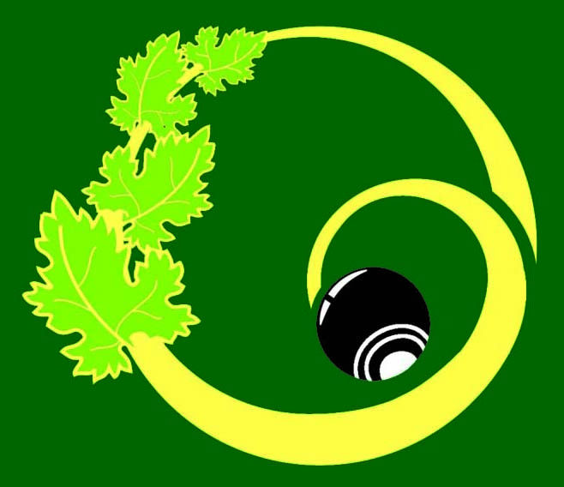

CENTRAL OTAGO BOWLS INC

NOTICE OF GENERAL MEETING ON
On 25 May 6.00pm
at Cromwell Bowling Club

AGENDA
ROLL CALL: Centre Delegates

APOLOGIES:

REMITS TO BE VOTED ON:

BANNOCKBURN BOWLNG CLUB:
- Saturday Pennants:
“That Saturday Pennants commence at 1.00pm”

- Premier and Div 1 Pennants:
“That there be two double header rounds in the Saturday Premier Division and three double header rounds in Division One. Double header not to be played in the first two rounds of competition.”

- Premier and Div 1 Pennants:
“A player is ineligible to play in Division One or Division Two men’s pennants, if they have played 5 rounds of Premier grade.

OTHER:

